
CHARLES DARWIN UNIVERSITY
SYDNEY CAMPUS
Unit Title and Code
PRT563 ADVANCED DATA MANAGEMENT
Unit Lecturer
Abdallah Al-Tawara

Assessment Title
Group Report – Assessment 4

Group Members
Nazia Afrin
Manisha Gautam
Sansuwa Shrestha
Salin Panta

Table of Contents
Table of Contents 2
1. Introduction 3
2. Methodology 3
3. Graph Database Model 5
4. Graph Database Implementation 6
4.1 Graph Database Import queries 6
4.1.1. Define Constrain 6
4.1.2. Importing Data 7
4.1.3. Database Relationship 8
4.1.4. Graph Database Result 10
5.Graph Database Business Case 11
5.1 Business Case 1 11
5.2 Business Case 2 12
5.3 Business Case 3 14
5.4 Business Case 4 16
6. Centrality Algorithm 18
Centrality Algorithm Findings 21
7. Similarity Algorithm 22
8. Limitation and lesson learnt 28
9. Conclusion 29
10. Contribution Matrix 30

Introduction
This report continues the Human Resource Management System that our group designed and implemented as a relational (SQLite) database in Assessment 2. As the university grows, most of the questions HR and academic managers ask are about connections rather than individual rows: who reports to whom, who reviewed whom, which tutors teach which units across which campuses, and who could cover for a colleague on leave. In the relational design, these queries require multiple joins, and recursive questions, such as "What is the full reporting chain above this person?", necessitate the use of recursive SQL. To better manage the database, the university has therefore nominated Neo4j (a native property-graph database) as the target platform, because it stores relationships directly. So, the cost of following a relationship does not depend on the total size of the database. The report covers the five assessment tasks: translating the EER model into a graph model, migrating the data with Cypher import scripts and indexes, four business query use cases of increasing complexity, a centrality analytics use case and a similarity analytics use case, all using the Neo4j Graph Data Science (GDS) Library.

Methodology
In this section we present the exact workflow and methodology on how we develop the required graph models and databased and how we developed algorithms. The assignment began with reviewing the existing relational database design and exporting its 17 tables into CSV files. We then modelled the graph database by converting entities into nodes, foreign keys and junction tables into relationships, and EER subtypes into additional labels. Next, we implemented the graph in Neo4j using constraints, indexes, and `LOAD CSV`, verified the imported data, and developed four Cypher queries representing different business use cases. We then used the Neo4j Graph Data Science library to apply centrality and similarity algorithms, comparing and interpreting their results. Finally, we compiled the findings, methodology, and individual contributions into a group report. Throughout the assignment, we used a GitHub repository to maintain the codebase, organize project files, track changes, and manage individual contributions collaboratively. Additionally, we have used Arrows.app and Mermaid graph generator to generate our graphs.
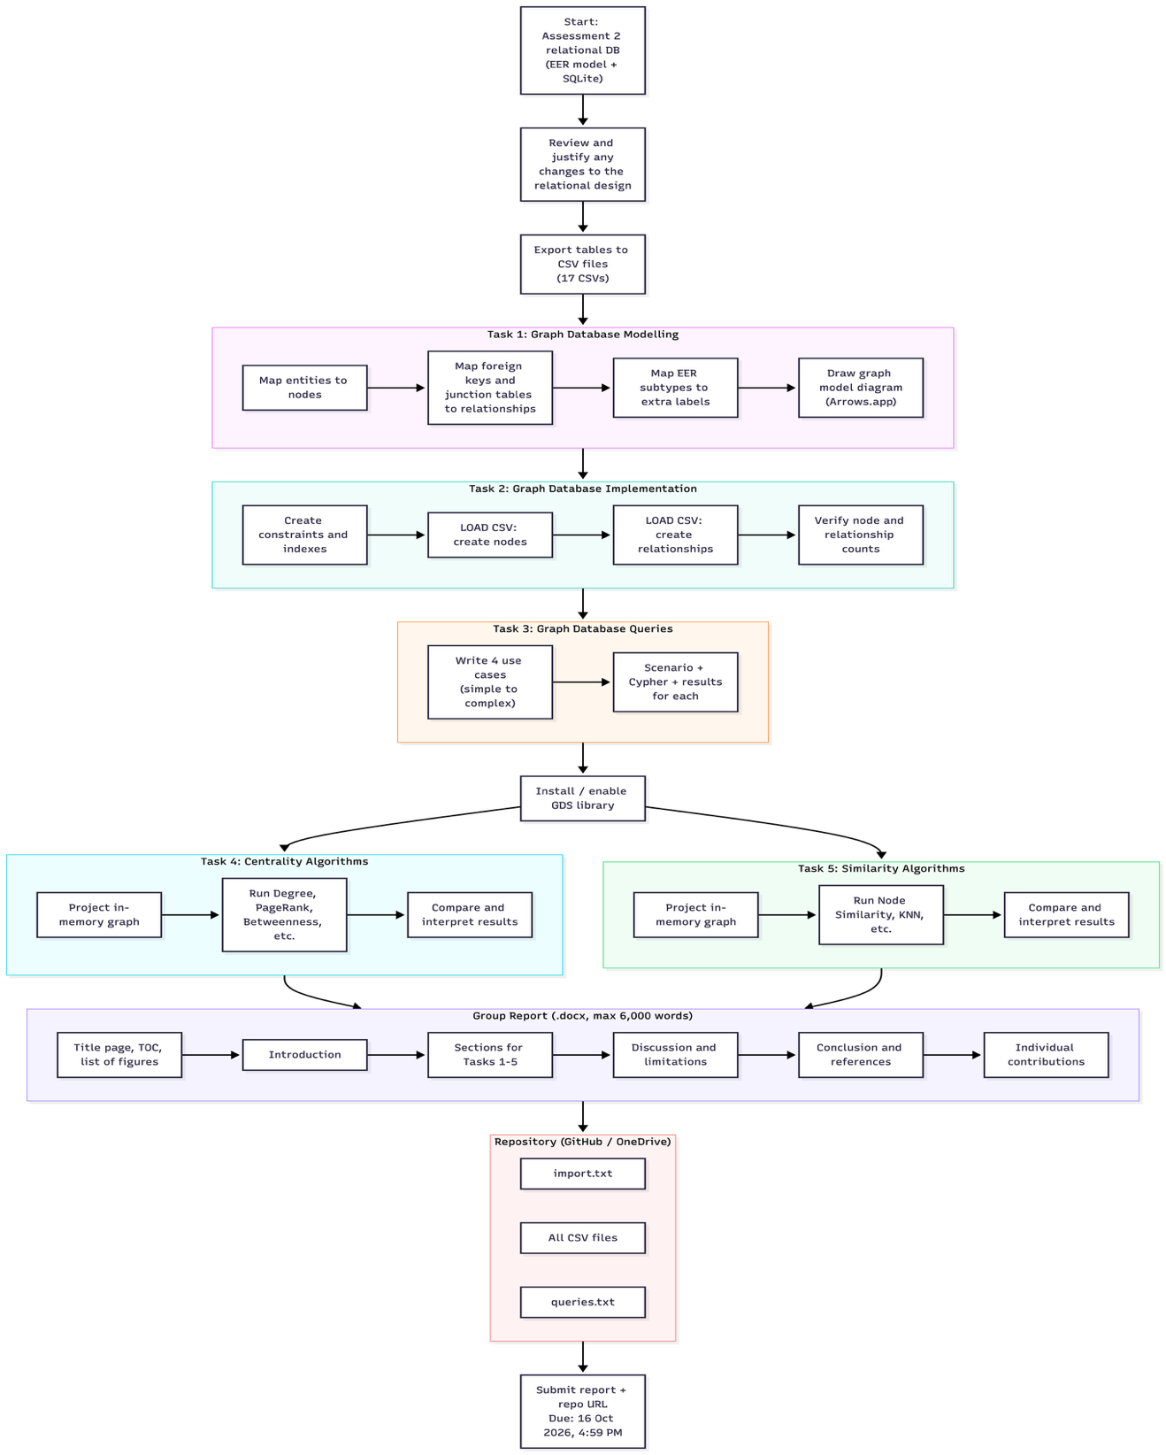
Figure 1: Project workflow

Graph Database Model
In this section we present the graph Database model, we have translated our EER diagram into a Graph Database model. The entities are represented as nodes, and the arrows present their relationships. The translated graph databased shows our entities and how they are connected to each other via arrows, The employee entity is our central entity which connect to campus, position, qualification, department and other core entities. Each relationship is defined by their respective roles with other entities. For example, and Employee can be located at a campus which is represented by employee located campus with arrow signs. The graph also connects Campus, UnitOffering, Unit, and Timesheet entities, providing a basis for analyzing academic delivery across campuses and investigating teaching activity and staffing. Overall, the graph contains more integrated, meaningful visual presentation of the database architecture. This architecture helps understand the relationship and entity dependency at a root level. The Graph model also supports an easy view of the academic and administrative operation of this project.
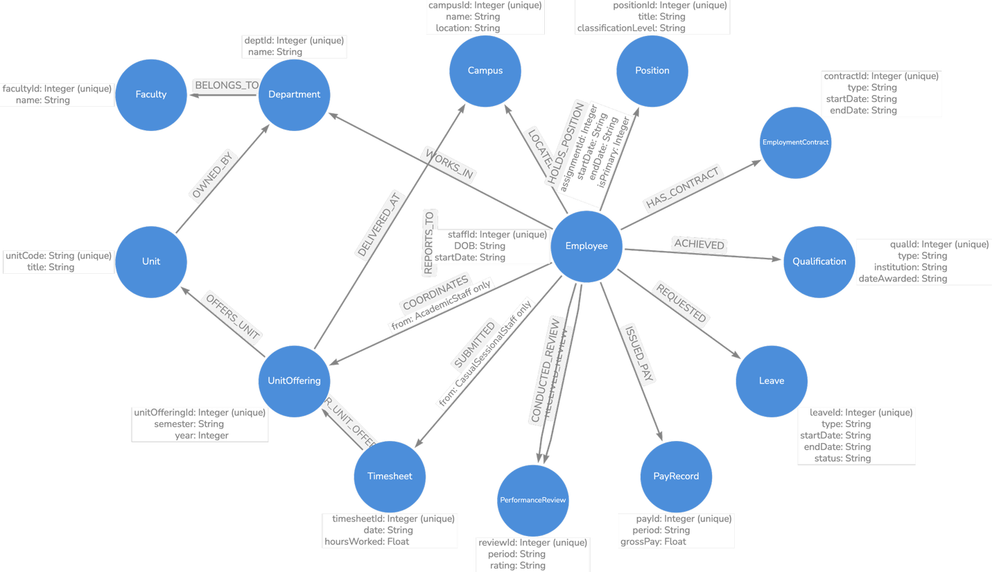
Figure 2: Translated Graph Database

Graph Database Implementation
This section we present the graph model from our existing database data. A systematic data collection that highlights the connections between the various data elements is called a graph database. Mathematical graph theory is used by the NoSQL database to display data linkages. Graph databases store data as a network of entities and relationships, in contrast to relational databases, which store data in unflexible table structures. Because these databases are more suited for simulating real-world situations, they frequently offer greater performance and flexibility (AWS, n.d.).
Figure 3 presents the Graph Database Employee Management System, illustrating how employee records are interconnected with organizational and employment-related entities through explicitly defined relationships. This structure enables user to understand and view employee managements, performance review, academic qualification, employment contract etc. By traversing this graph and HR can review and investigate employee performance, employe dependencies, manage payrolls and records, support workforce management activities without looking into tables over and over again. Moreover, HR can monitor employee performances, workload distribution and allocation.

4.1 Graph Database Import queries
This section we present and explain how we have implemented the graph database from our EER diagram our set constraints and relationship between nodes.

Define Constrain
At first, we define appropriate constraints to our database tables which includes creating unique constraints and indexes. Our project has several tables with unique identification, for each table we have defined table id as a unique property.

// 1. UNIQUE CONSTRAINTS & INDEXES
CREATE CONSTRAINT IF NOT EXISTS FOR (f:Faculty) REQUIRE f.facultyId IS UNIQUE;
CREATE CONSTRAINT IF NOT EXISTS FOR (d:Department) REQUIRE d.deptId IS UNIQUE;
CREATE CONSTRAINT IF NOT EXISTS FOR (c:Campus) REQUIRE c.campusId IS UNIQUE;
CREATE CONSTRAINT IF NOT EXISTS FOR (e:Employee) REQUIRE e.staffId IS UNIQUE;
CREATE CONSTRAINT IF NOT EXISTS FOR (p:Position) REQUIRE p.positionId IS UNIQUE;
CREATE CONSTRAINT IF NOT EXISTS FOR (u:Unit) REQUIRE u.unitCode IS UNIQUE;
CREATE CONSTRAINT IF NOT EXISTS FOR (uo:UnitOffering) REQUIRE uo.unitOfferingId IS UNIQUE;
CREATE CONSTRAINT IF NOT EXISTS FOR (ec:EmploymentContract) REQUIRE ec.contractId IS UNIQUE;
CREATE CONSTRAINT IF NOT EXISTS FOR (q:Qualification) REQUIRE q.qualId IS UNIQUE;
CREATE CONSTRAINT IF NOT EXISTS FOR (l:Leave) REQUIRE l.leaveId IS UNIQUE;
CREATE CONSTRAINT IF NOT EXISTS FOR (t:Timesheet) REQUIRE t.timesheetId IS UNIQUE;
CREATE CONSTRAINT IF NOT EXISTS FOR (pr:PayRecord) REQUIRE pr.payId IS UNIQUE;
CREATE CONSTRAINT IF NOT EXISTS FOR (rev:PerformanceReview) REQUIRE rev.reviewId IS UNIQUE

Figure 1 : Defining constraints

Importing Data

After defining all the constraint, we import our data from csv to the Neo4j Database. We have kept all of our csv files in GitHub; we directly load from GitHub. To achieve this, we have used the build in function from Neo4j “LOAD CSV WITH HEADERS FROM” Module. We present a snippet of the code here; the rest of the code is referred in Appendix section. We import all of our tables one by one then we establish the relationship. The following code shows how we have imported real data from cvs files to our Neo4j Databse.

// --- 2.1 Faculty Nodes ---
LOAD CSV WITH HEADERS FROM 'https://raw.githubusercontent.com/Nowshin021/Employee_management_assingment/nazia/csv_files/Faculty.csv' AS row MERGE (f:Faculty {facultyId: toInteger(row.facultyId)}) ON CREATE SET f.name = trim(row.name);
// --- 2.2 Department Nodes ---
LOAD CSV WITH HEADERS FROM 'https://raw.githubusercontent.com/Nowshin021/Employee_management_assingment/nazia/csv_files/Department.csv' AS row MERGE (d:Department {deptId: toInteger(row.deptId)}) ON CREATE SET d.name = trim(row.name);

Figure 2: Importing data into Neo4j

Database Relationship

Our Next step is to define the database relationship by adding cypher queries. In the following section we have presented two of our cypher example queries showing how we have mapped the relationship into Graph Database. The complete code can be found in the appendix section. After the successful completion of the data loading, we wrote code to re-read the csv files and converting each foreign key into a directed relationship. Each node uses the MATCH function to find the node connected, using their unique IDs, which are fast to look up because of the uniqueness constraints created earlier. It then uses MERGE to create the relationship, so running the script again does not create duplicates.
// --- 3.1 Department belongs to Faculty ---
LOAD CSV WITH HEADERS FROM 'https://raw.githubusercontent.com/Nowshin021/Employee_management_assingment/nazia/csv_files/Department.csv' AS row
MATCH (d:Department {deptId: toInteger(row.deptId)})
MATCH (f:Faculty {facultyId: toInteger(row.facultyId)})
MERGE (d)-[:BELONGS_TO]->(f);

// --- 3.2 Employee works in Department and is located at Campus
LOAD CSV WITH HEADERS FROM 'https://raw.githubusercontent.com/Nowshin021/Employee_management_assingment/nazia/csv_files/Employee.csv' AS row
MATCH (e:Employee {staffId: toInteger(row.staffId)})
MATCH (d:Department {deptId: toInteger(row.deptId)})
MATCH (c:Campus {campusId: toInteger(row.campusId)})
MERGE (e)-[:WORKS_IN]->(d)
MERGE (e)-[:LOCATED_AT]->(c);
Table 3 : Stablishing relationship among the table

Graph Database Result

After we have imported all our data and adding the node based relationship based on the foreign keys , we ran the following code CALL db.schema.visualization();This function calls the database and visualizes the nodes and their relationship with other nodes via arrows, The following graph shows the Graph Database of the proposed system. The graph is a sixteen-node graph presenting our sixteen tables and they are connected by their foreign keys. The employee node is connected to a number of nodes and their relationship is defined and denoted by arrows and a text presenting what is the role of the employee. The self-loops are the arrows that leave a node and come back to the same node. They appear on Employee, AcademicStaff and ProfessionalStaff, and all three are REPORTS_TO. Each loop means one staff member reports to another staff member of the same type.
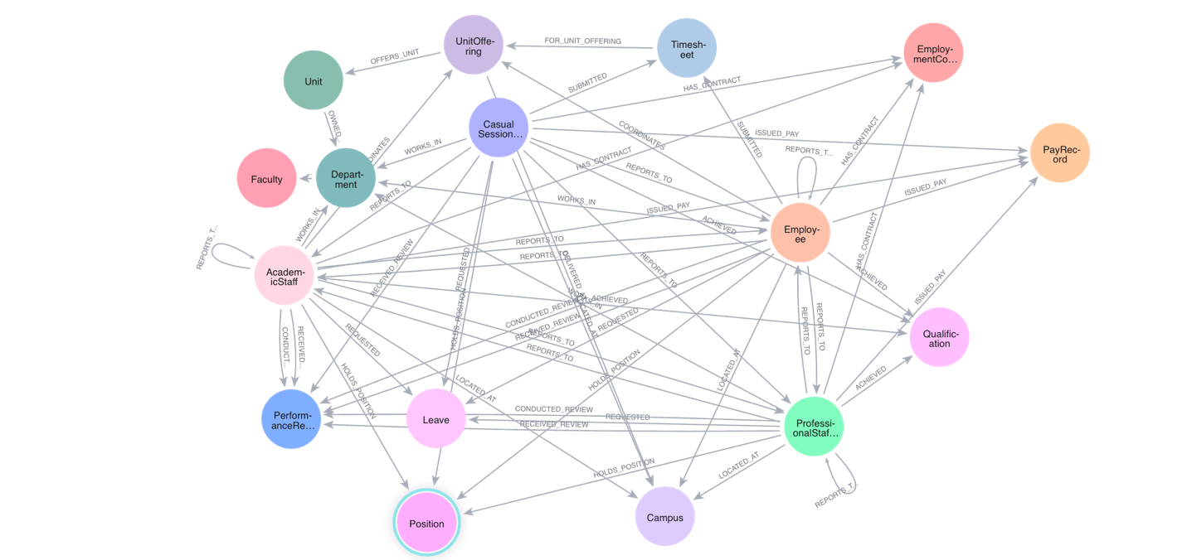
Figure 3: Graph Database Employee Management System

Graph Database Business Case
In this section we present four key business cases that graph database can solve. We have analyzed our data and write cypher queries to implement business cases and their result and explained their impact on the project.

Business Case 1
For executive workforce promotion and retention planning, HR leadership needs to identify high-performing staff who achieved superior performance ratings, trace the reviewer who conducted the appraisal, check contract renewal and permanency status, and collect all verified academic qualifications held by the employee. This Cypher query represents an advanced Talent Evaluation and Leadership Review Hierarchy use case designed to support HR decision-making for employee promotion and retention planning. It identifies high-performing employees based on their performance review ratings, traces the employees who conducted their appraisals, and retrieves their current positions, contract types, contract end dates, and verified academic qualifications.
MATCH (e:Employee)-[:RECEIVED_REVIEW]->(rev:PerformanceReview)
MATCH (reviewer:Employee)-[:CONDUCTED_REVIEW]->(rev)
OPTIONAL MATCH (e)-[:HAS_CONTRACT]->(ec:EmployementContract)
OPTIONAL MATCH (e)-[:ACHIEVED]->(q:Qualification)
OPTIONAL MATCH (e)-[:HOLDS_POSITION]->(pos:Position)
WHERE rev.rating IN ['Exceeds Expectations', 'Outstanding', 'High Performing']
OR rev.rating CONTAINS 'Exceed'
RETURN e.staffId AS StaffID,
e.name AS HighPerformer,
pos.title AS CurrentPosition,
rev.rating AS PerformanceRating,
rev.period AS ReviewPeriod,
reviewer.name AS ReviewedBy,
ec.type AS ContractType,
CASE
WHEN ec.endDate IS NULL OR ec.endDate = '' THEN 'Permanent / Indefinite'
ELSE ec.endDate
END AS ContractEndDate,
collect(DISTINCT q.type + ' (' + q.institution + ')') AS Qualifications
ORDER BY HighPerformer;
Figure 4: Business Case 1 Query
The query uses mandatory matches to connect employees with their performance reviews and reviewers, while optional matches retrieve contract, qualification, and position details when available. It then filters for employees rated Exceeds Expectations, Outstanding, or High Performing, including ratings containing “Exceed,” and consolidates each employee’s qualifications into a list. The results are ordered alphabetically by employee name, providing HR leadership with a consolidated view of employee performance, qualifications, and employment status to support informed promotion and workforce retention decisions.
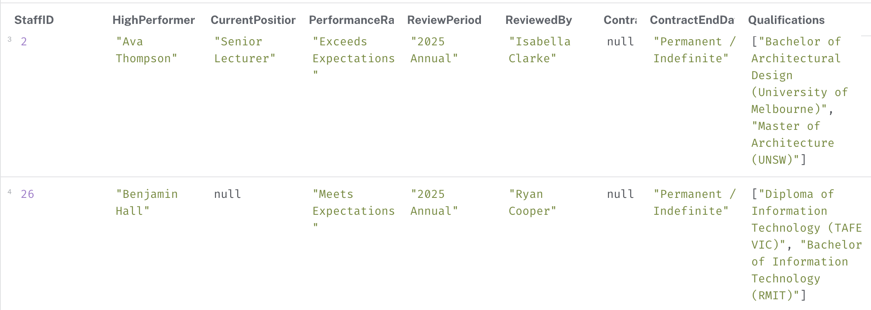
Figure 5: Business Case 2 Output

5.2 Business Case 2
This use case focuses on multi-hop unit offering delivery and teaching staffing, where the Academic Registrar monitors unit offerings across multiple campuses. The query traverses the relationships between unit offerings, their parent units, delivery campuses, and associated timesheet logs to calculate the total teaching hours recorded for each offering and consolidate the list of academic instructors involved. This enables the university to track teaching workloads, understand staffing allocation, and monitor unit delivery across campuses.
This high-complexity Multi-Hop Unit Offering Delivery and Teaching Staffing use case helps the Academic Registrar monitor unit offerings across multiple campuses and evaluate teaching workloads. The Cypher query traverses relationships between unit offerings, their parent units, delivery campuses, timesheet records, and the employees who submitted those timesheets. For each offering, it retrieves the unit code and title, semester, campus location, total number of distinct timesheet logs, total teaching hours recorded, and a consolidated list of instructors involved.
MATCH (uo:UnitOffering)-[:OFFERS_UNIT]->(u:Unit)
MATCH (uo)-[:DELIVERED_AT]->(c:Campus)
OPTIONAL MATCH (t:Timesheet)-[:FOR_UNIT_OFFERING]->(uo)
OPTIONAL MATCH (staff:Employee)-[:SUBMITTED]->(t)
RETURN u.unitCode AS UnitCode,
u.title AS UnitTitle,
uo.semester + ' ' + toInteger(uo.year) AS Semester,
c.name AS CampusLocation,
count(DISTINCT t) AS TotalTimesheetLogs,
coalesce(sum(t.hoursWorked), 0.0) AS TotalTeachingHoursLogged,
collect(DISTINCT staff.name) AS InstructorsInvolved
ORDER BY UnitCode, Semester;

Figure 6: Business Case 2 Query
Optional matches ensure that offerings without timesheet records or associated instructors can still appear in the results. Finally, the results are sorted by unit code and semester, enabling the Academic Registrar to compare teaching activity, monitor staffing distribution, and support academic workload planning across campuses
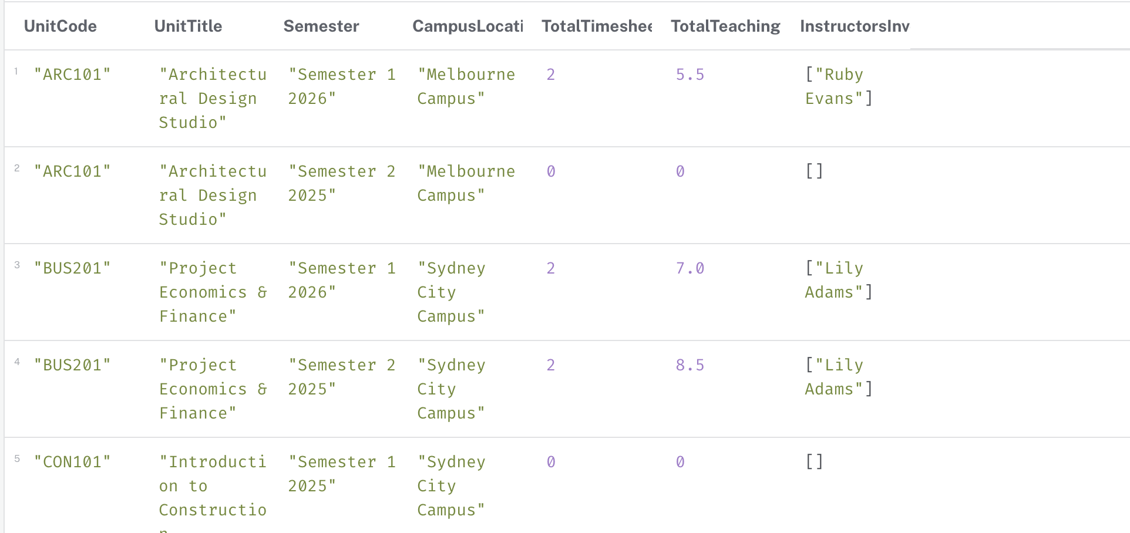
Figure 7: Business Case 2 Output

5.3 Business Case 3
Department Staff Directory & Campus Allocation
Scenario:
HR management needs a consolidated directory of university employees. This query connects employees with their departments, faculties and campuses, while retrieving their position assignments. It supports organizational reporting and workforce allocation across the university.
Query:
MATCH (e:Employee)-[:WORKS_IN]->(d:Department)
MATCH (d)-[:BELONGS_TO]->(f:Faculty)
MATCH (e)-[:LOCATED_AT]->(c:Campus)
OPTIONAL MATCH (e)-[hp:HOLDS_POSITION]->(p:Position)
WITH e, d, f, c, hp, p
ORDER BY hp.startDate
WITH e, d, f, c,
collect(CASE WHEN hp.isPrimary = 1 THEN p.title END)[0] AS PrimaryPosition,
collect(CASE WHEN p IS NOT NULL
THEN p.title + ' (' + hp.startDate + ' to ' + coalesce(hp.endDate, 'present') + ')'
END) AS Assignments
RETURN
e.staffId AS StaffID,
e.name AS EmployeeName,
PrimaryPosition,
reduce(s = '', x IN Assignments | s + CASE WHEN s = '' THEN '' ELSE '; ' END + x) AS PositionHistory,
d.name AS Department,
f.name AS Faculty,
c.name AS Campus
ORDER BY Faculty, Department, EmployeeName;

OUTPUTS:
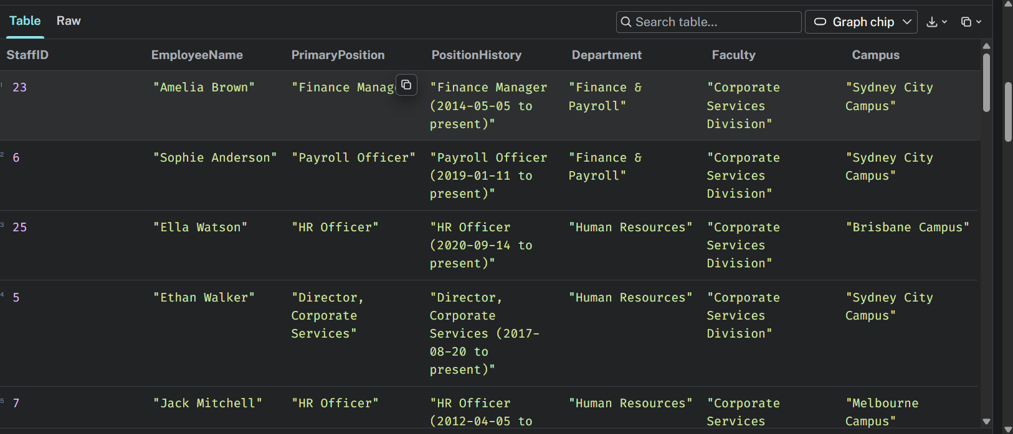
Figure 8: Business Case 3 Output

5.4 Business Case 4
Casual Staff Workload & Payroll Analytics
Scenario:
HR and payroll staff need to monitor casual sessional employees' recorded hours and estimate their gross pay. This query aggregates submitted timesheets for each employee and calculates estimated pay using the recorded hourly rate. The result supports workload monitoring and preliminary payroll analysis.
Query:
MATCH (e:Employee:CasualSessionalStaff)-[:WORKS_IN]->(d:Department)
OPTIONAL MATCH (e)-[:SUBMITTED]->(t:Timesheet)
WITH e, d,
count(t) AS TimesheetCount,
coalesce(sum(t.hoursWorked), 0.0) AS TotalHours
RETURN
e.staffId AS StaffID,
e.name AS StaffName,
d.name AS Department,
e.hourlyRate AS HourlyRate,
e.maxHoursPerWeek AS MaxHoursPerWeek,
TimesheetCount,
round(TotalHours * 100) / 100 AS TotalHours,
round(TotalHours * e.hourlyRate * 100) / 100 AS EstimatedGrossPay
ORDER BY EstimatedGrossPay DESC;

OUTPUTS:
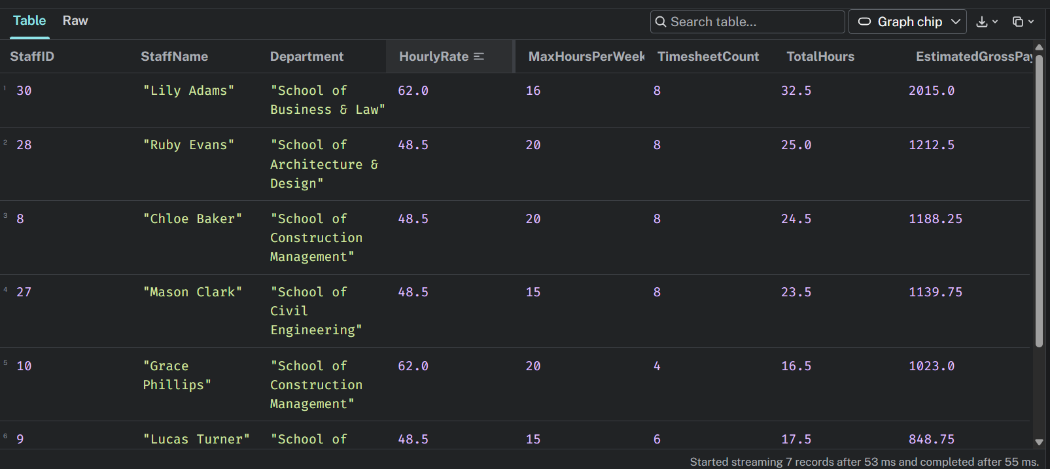
Figure 9: Business Case 4 Output

Centrality Algorithm

This section we present the centrality algorithm for our database system. The Neo4j Graph Data Science (GDS) library contains many graph algorithms. The algorithms are divided into categories which represent different problem classes. A variety of graph algorithms are offered by Neo4j Graph Data Science (GDS) to analyze relationships and find significant patterns within a network. Centrality, community discovery, similarity, path finding, DAG methods, node embeddings, topological link prediction, and the Pregel API are the categories into which these algorithms fall. Centrality algorithms quantify the significance or impact of nodes in a graph, assisting in the identification of important entities based on elements including their position, connection, and function in information flow. When combined, these techniques facilitate data-driven decision-making, network exploration, and graph-based analytics (Neo4J, n.d.). There are multiple types of centrality algorithm are available such as
- Article Rank
- Articulation Points
- Betweenness Centrality
- Bridges
- CELF
- Closeness Centrality
- Degree Centrality
- Eigenvector Centrality
- Harmonic Centrality
- Page Rank
- HITS
After researching multiple centrality algorithms, we have decided to move forward with Degree centrality. The degree centrality algorithm counts the number of incident edges at each node that it traverses. This measure of how connected the node is can in turn indicate the node's importance and level of influence in the network (AWS, n.d.). For degree centrality, higher values mean that the node is more central. Each centrality measure indicates a different type of importance. Degree centrality shows how many connections a person has. They may be connected to lots of people at the heart of the network, but they might also be far off on the edge of the network. (Science Direct, n.d.)
Business Case: Staff Responsibility Load
In order to identify potential workload mismatches and assist with succession planning in the event that important personnel go, the HR department seeks to identify individuals who hold the highest level of responsibility within the company. Three factors are combined to determine each employee's responsibility load: the number of individuals who report to them through incoming `REPORTS_TO` relationships, the number of performance reviews they have conducted through `CONDUCTED_REVIEW` relationships, and the number of unit offerings they coordinate through `COORDINATES` relationships. HR can discover workers with high responsibility loads and make well-informed decisions on workload distribution and organizational continuity by examining these relationships in the Neo4j graph database.
Step 1: Projecting the memory graph
CALL gds.graph.project(
'staffResponsibility',
['Employee', 'PerformanceReview', 'UnitOffering'],
{
MANAGES: { type: 'REPORTS_TO', orientation: 'REVERSE' },
CONDUCTED_REVIEW: { type: 'CONDUCTED_REVIEW', orientation: 'NATURAL' },
COORDINATES: { type: 'COORDINATES', orientation: 'NATURAL' }
}
)
YIELD graphName, nodeCount, relationshipCount;

Step 2: Streaming the sources with background
CALL gds.degree.stream('staffResponsibility')
YIELD nodeId, score
WITH gds.util.asNode(nodeId) AS e, score
WHERE e:Employee AND score > 0
RETURN e.staffId AS StaffID,
e.name AS Employee,
[l IN labels(e) WHERE l <> 'Employee'][0] AS StaffType,
COUNT { (e)<-[:REPORTS_TO]-() } AS DirectReports,
COUNT { (e)-[:CONDUCTED_REVIEW]->() } AS ReviewsConducted,
COUNT { (e)-[:COORDINATES]->() } AS OfferingsCoordinated,
score AS DegreeCentrality
ORDER BY DegreeCentrality DESC, Employee;

Step 3: Comparing Node Relationship
CALL gds.degree.stream('staffResponsibility', { relationshipTypes: ['MANAGES'] })
YIELD nodeId, score
WHERE score > 0
RETURN gds.util.asNode(nodeId).name AS Manager, score AS DirectReports
ORDER BY DirectReports DESC;
Step 4: Writing the code back to the database to view as a table
CALL gds.degree.write('staffResponsibility', { writeProperty: 'responsibilityDegree' })
YIELD nodePropertiesWritten, centralityDistribution;
MATCH (e:Employee) WHERE e.responsibilityDegree > 0
RETURN e.name, e.responsibilityDegree ORDER BY e.responsibilityDegree DESC LIMIT 5;

Centrality Algorithm Findings

The degree centrality analysis measured each employee's responsibility load by counting their direct reports, the performance reviews they have conducted and the unit offerings they coordinate in the projected graph. Henry Nguyen recorded the highest score (15: 5 direct reports, 8 reviews and 2 coordinated offerings), followed by Liam Carter (12), Olivia Bennett (10), Isabella Clarke (9) and Ethan Walker (8), while most other staff scored close to zero. This shows that organizational responsibility is concentrated in a small group of senior staff who act as central hubs for supervision, appraisal and teaching coordination. Henry Nguyen and Liam Carter carry all three types of responsibility, making them potential single points of failure whose absence would disrupt reporting lines, review cycles and unit delivery at the same time. Olivia Bennett and Ethan Walker score highly only through management and review duties. For HR, these results suggest redistributing performance review duties more evenly, prioritizing succession planning for the highest-scoring staff and monitoring their workload to reduce burnout and operational risk.
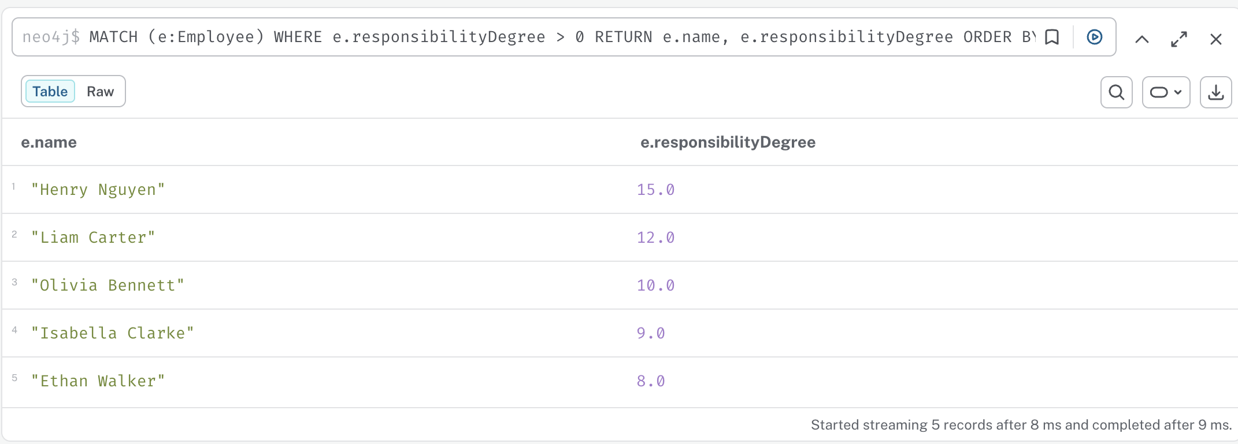
Figure 9 : Degree Centrality Algorithm

Similarity Algorithm
Similarity algorithm computes the similarity of the pairs of nodes based on the neighbors they are connected to or the properties. The Neo4j GDS library includes following similarity algorithms like:
- Node Similarity
- Filtered Node Similarity
- K-Nearest Neighbors
- Filtered K-Nearest Neighbors
Business Case: Staff Responsibility Load
The degree centrality algorithm identified Henry Nugen and Liam Carter as the most responsible personnel. This situation clarifies that most of the tasks were assigned to these people, which increases the likelihood of burnout and attrition among them. It creates a severe vulnerability because these people are the single point of failure for report analysis, review, coordination, and supervision.
To overcome this situation, HR should develop an automated solution to distribute the workload among other individuals as well. However, assigning important tasks to a random person who might not be able to handle tasks like Henry Nugen and Liam Carter might create an operational risk. Now, the new challenge is to find nodes functionally equivalent to other peers. For this, similarity algorithms can be used to find similar nodes.
In this business scenario, using Node Similarity (Jaccard Index), we examine individuals based on shared qualifications (:ACHIEVED), departmental ties (:WORKS_IN), and the position (:POSITION). This leads HR to:
- Offload supervision and performance review duties from Henry Nugen and Liam Carter to highly skilled, underutilized peers.
- Identify an immediate, qualified candidate to replace key personnel on leave.
This is because Jaccard Indexing does not tolerate any disparities in candidate scope. This means that if an inexperienced staff member has two attributes that, by coincidence, match two of Henry's six attributes, a simple formula such as the Overlap Coefficient will give him a score of 100%. This is why Jaccard ensures that all combined attributes are considered, thus preventing HR from assigning an inexperienced person to replace Henry.
Step 1: In-memory Projection
To compare staff capabilities accurately, we project an in-memory graph in Neo4j GDS containing (:Employee), (:AcademicStaff), (:Qualification), (:Department) and (:Position) nodes connected by undirected edges.

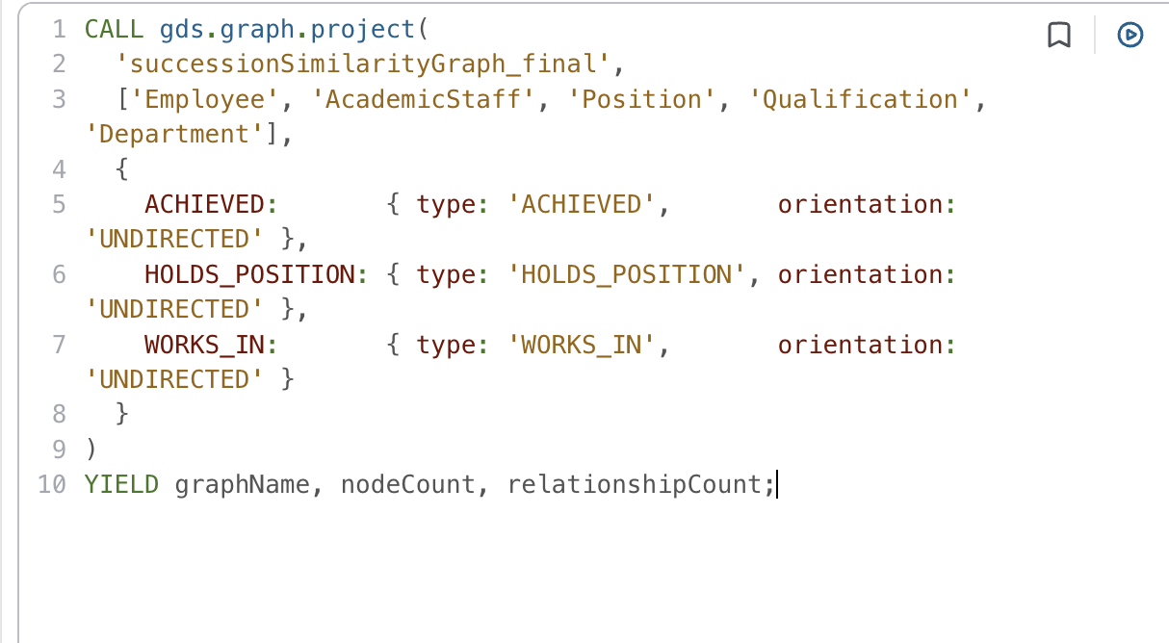

Why were specific nodes selected?
However, in the in-memory projection, some of these nodes were included, whereas others were not. These reasons are outlined below:
i) Employee and AcademicStaff were chosen for matching pairs.
ii) Position was chosen for matching job titles and classifications.
iii) Qualification was selected to evaluate academic degrees and professional accreditations earned by staff members.
iv) And finally, department was selected to evaluate organisational units and faculties within the university.
In addition, nodes that represent single event entities like single Performance Review, single Unit Offering, or single Timesheet were purposely left out because single event nodes are specific to an employee. If projected, there will never be a point where two different employees have a common target node, resulting in zero similarity according to Jaccard Similarity.
Why were specific Relationships selected?
- To evaluate whether a candidate can realistically step into a central leader’s role, three categorical relationships were projected into memory.
- HOLDS_POSITION verifies that a candidate operates at an equivalent or adjacent classification level. High-level responsibilities (such as conduction performance reviews or directing curriculum) require appropriate job seniority.
- ACHIEVED assesses baseline academic qualifications and field of degree.
- WORKS_IN indicates organizational unit compatibility. Employees who work in the same department have similar administrative processes, faculty governance, and culture, which facilitates an easier handover as backup delegates.
Step 2: Identifying deserved peer
Next, we execute gds.nodesimilarity to identify the top replacement candidate.
In the following query, we have mentioned the parameters for the nodeSimilarity algorithm as:
- SimilarityCutoff to 0.01 because a low cutoff ensures that even sparse academic networks are captured, preventing viable candidates from being missed.
- DegreeCutoff to 1 because it requres a node to have at least 1 connectioni in the projected graph before calculating similariy. This skips isolated or unassigned staff nodes, conserving memory and accelerating execution time.
- TopK to 5 which limits the output to the top 5 highest scoring candidates for each target staff member.
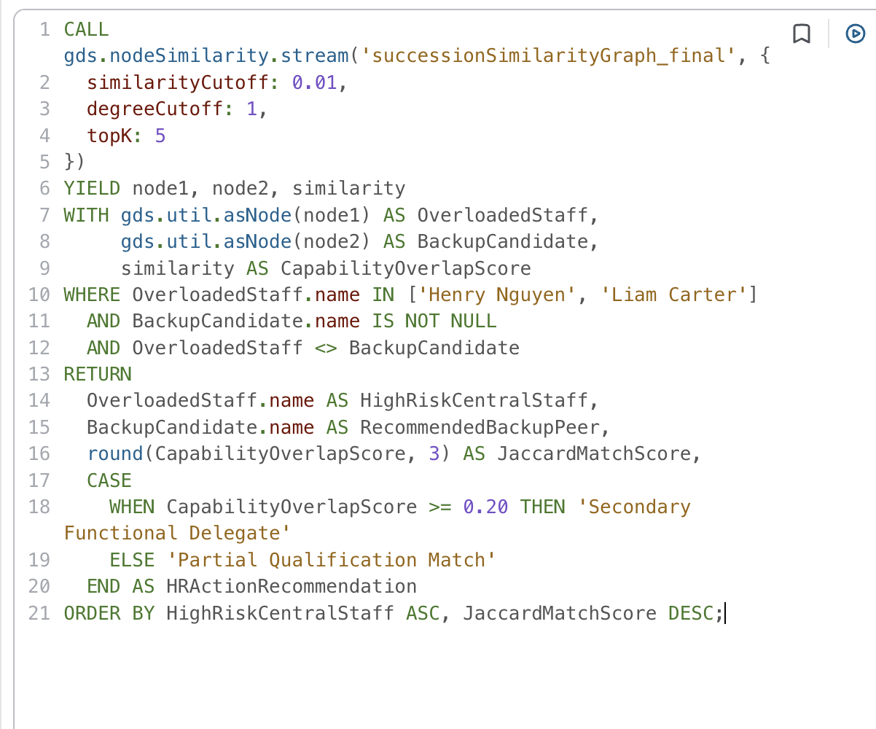
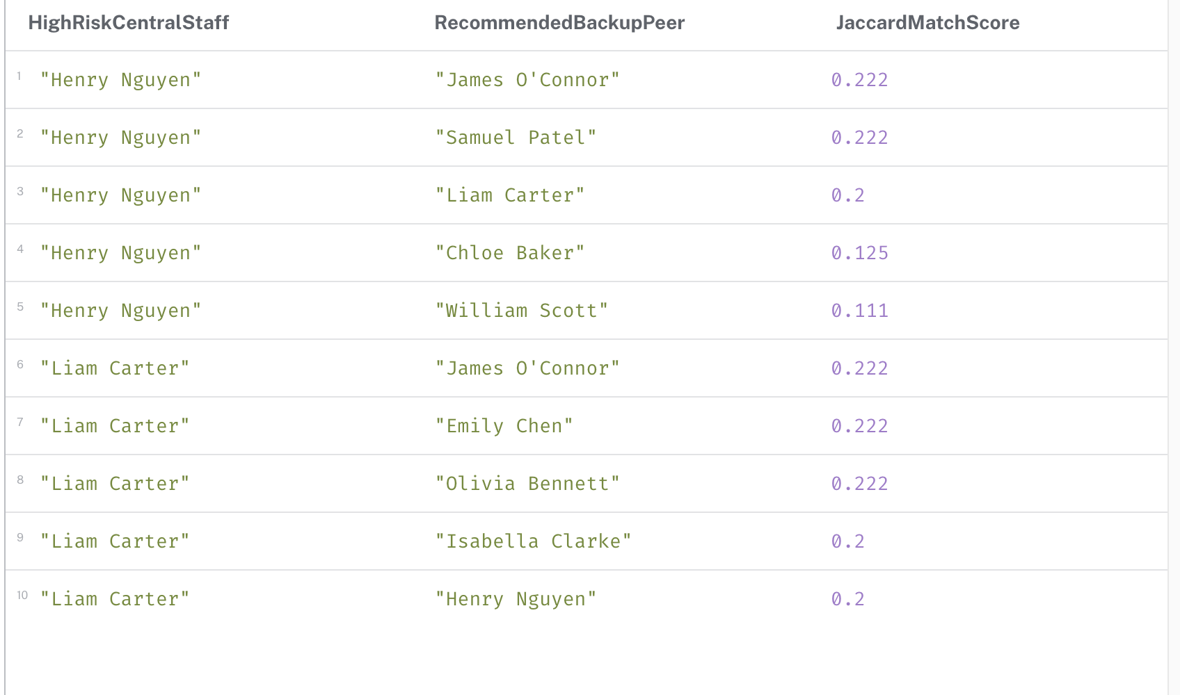
Similarity Algorithm Findings
The similarity algorithm showed that there is no single “magic clone” in the company who shares 100% of Henry or Liam’s exact background. Instead, candidate scores clustered around a 22.2% match rate. This means HR cannot simply hand off all of Henry or Liam’s duties to one individual.
James O’Connor achieved a top match score of 22.5% for both Henry and Liam because he holds the same senior executive rank as they do. While James does not teach in the same field, his high organisational rank makes him the perfect backup to absorb administrative tasks.
Similarly, Samuel Patel matched Henry 22.2% because Samuel belongs to the department and has the same academic level. This makes Samuel the ideal peer to take over course coordination and teaching.
This is why the suggested solution is for HR to redistribute Henry’s and Liam’s responsibilities among other members of the team. The HR manager must transfer all reporting duties to the management of other senior managers such as James, while the course and curriculum coordination is taken care of by departmental experts like Samuel.

Limitation and Lesson Learnt

In this section we explore what we have learnt from this project. We have successfully migrated our relational database into a graph database that uses no SQL queries. This migration gave us an important lesson how graph database provides an overview of the whole database and the relationship among the table. In the relational database it is required to use multiple joins to find about the data and insights, however graph database can provide much clearer picture of the tables and their connection to adjacent tables. The migration also taught us the graph database depends on the design of the database itself. The core design is important, and it effect the graph and the relationship among the nodes.
However, there are few limitations presents in this project, The dataset has 450 records and 30 employees. The database design fulfills the requirements of the project however a production level a typical database will have more tables and more datapoints which will be more complicated in real life scenario. The database was loaded from direct CSV files which is a one-time use only, In production level data could change, and new data could be added anytime this project is limited to work with the only data present in the CSV. If there are any data update the system needs to load the data again instead of updated or adding the new ones. This might make the this project very resource intensive as the data grows with time.

Conclusion
This report has successfully demonstrated the migration of the University HR Management System from a relational SQLite database to a Neo4j graph database. The graph model better represents the complex relationships between employees, departments, qualifications, performance reviews, and teaching responsibilities that are central to university HR management.
The four business use cases demonstrated the power of Cypher queries for HR analytics, from basic staff directories to complex multi-hop relationship traversals. The centrality algorithms revealed that a small group of senior staff carry disproportionate responsibility loads, creating potential single points of failure. The similarity algorithms identified suitable peer replacements to support succession planning and workload redistribution.
The graph database approach proved superior to the relational model for relationship-heavy queries, eliminating the need for complex multi-table joins and recursive SQL. Future improvements could include expanding the graph model to capture historical changes to positions over time and implementing real-time analytics dashboards using Neo4j Bloom.

Individual Contribution

Nazia Afrin

Nazia wrote the Methodology section and created the project workflow diagram, which set out how the group would move from the Assessment 2 relational database to Neo4j. She then translated the EER model into the graph data model, deciding how entities, foreign keys, junction tables and EER subtypes would become nodes, relationships and labels, and produced the model diagram using Arrows.app. For the Graph Database Implementation section, she worked with Salin on the Cypher import scripts. Her part covered the uniqueness constraints, the LOAD CSV scripts that import each table as nodes, the scripts that create relationships between them, and verifying the final imported graph in Neo4j. She also set up and maintained the group’s GitHub repository, where the CSV files, import scripts and queries were stored and shared. In the Business Case section, she designed and wrote Business Case 1, which identifies high-performing staff for promotion and retention planning, and Business Case 2, which tracks unit offering delivery and teaching hours across campuses. Each one included the scenario, the Cypher query and an interpretation of the results. Finally, she developed the centrality analysis, selecting Degree Centrality to measure staff responsibility load and writing the GDS graph projection, the algorithm queries and the findings that identified the staff most at risk of overload.

Contribution Matrix

Topic | Contents | Team Member | Contribution
Introduction | 1 | Manisha | 100 %
Methodology | 2 | Nazia | 100 %
Graph Database Model | 3 | Nazia | 100 %
Graph Database Implementation | 4 | Nazia And Salin | 60 % + 40 %
Graph Database Import queries | 4.1 | Salin | 100 %
Define Constrain | 4.1.1 | Nazia | 100 %
Importing Data | 4.1.2 | Nazia | 100 %
Database Relationship | 4.1.3 | Nazia | 100 %
Graph Database Result | 4.1.4 | Nazia | 100 %
Graph Database business case | 5 | Nazia and Sansuwa | 50 % + 50 %
Business Case 1 | 5.1 | Nazia | 100 %
Business Case 2 | 5.2 | Nazia | 100 %
Business Case 3 | 5.3 | Sansuwa | 100%
Business Case 4 | 5.4 | Sansuwa | 100%
Centrality Algorithm | 6 | Nazia | 100 %
Similarity Algorithm | 7 | Salin | 100%
Database Schema Error Identification | -- | Salin | 100%
Schema and Logic Optimization. | -- | Salin | 100%
Relational database data entry error identification and correction | --- | Salin | 100%
Limitation and Lesson Learnt | 8 | Manisha
Conclusion | 9 | Sansuwa

References

